**Department of Computer Science**

[Advanced](http://portal.aiub.edu/Student/Section?q=DzbZQpy0bBLEleuWJjeVxA%3D%3D) Operating System Project, Fall 2016-2017

|  |  |  |  |
| --- | --- | --- | --- |
| Course Title | Advanced Operating System | Section | A |

**Group Members:**

|  |  |  |
| --- | --- | --- |
| Student ID | Name | Signature |
| **13-24001-2** | **Hasan, A. K. M. Abid** |  |
| **13-24061-2** | **Sohel, Shamim Reza** |  |
| **13-23997-2** | **Khan, Neamul Haque** |  |

**Project Title:**

|  |
| --- |
| Remote Fire Alarm |

[American International University-Bangladesh]

**Remote Fire Alarm**

This project is Called a "Remote Fire Alarm". When the fire is detected, the system will send an email pre-defined Fire Service E-Mail Address. So, fire service get alert from email instantly and come to the location and control the fire.

**Why This Project?:**

Sometimes when the fire is up in factory or any house, that time everyone getting panic. So, they forget to call fire service or they don't have collect the number of fire service on their mobile.   
So, we want to make it automatically system where fire service gets email when the fire is detected.

**Components:**

* Raspberry Pi 2 Model B
* microSD Card
* Flame Sensor Module( SEN-0018F)
* 15mm Red-Green LED
* Male to Female and Male to Male Jumper
* Bread Board

**Connection:**

We user GPIO Ports of Raspberry Pi to connect our Flame Sensor Module and LED Light from the Bread Board.

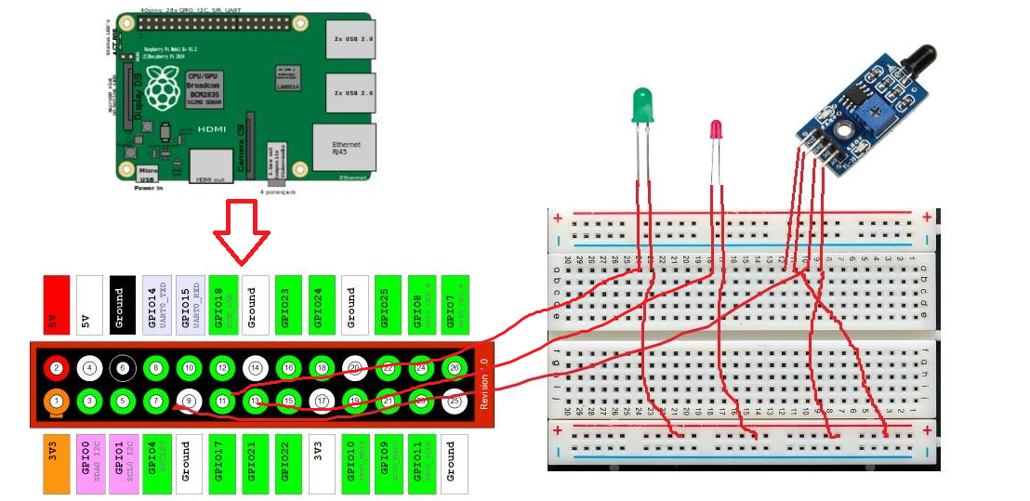

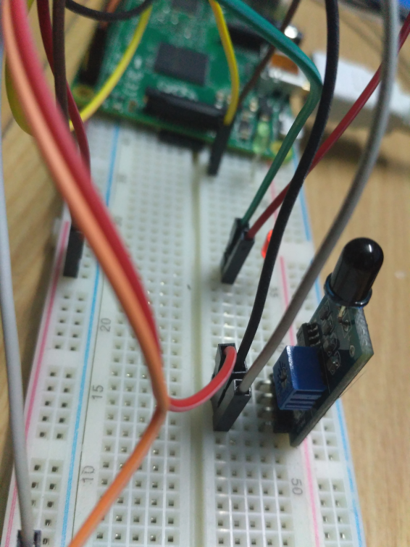

* The 3.3v from Raspberry pi provide power to Flame Sensor Module and LED's.
* We connect Flame Sensor Module to Raspberry pi on GPIO7
* Red Led is connected with GPIO13
* Green Led is connected with GPIO11
* We also use ground connection

**Configuration:**

* Downloaded Raspbian Jessie with PIXEL from <https://www.raspberrypi.org/> .
* Then downloaded SD Card Formatter and Win32diskimager for windows.
* Formatted the microSD card with SD Card Formatter and Using win32diskimager burned Raspbian jessie in the microSD card.
* After setup jessie and the above connection connected the pi with monitor via HDMI to VGA(For that we need to change some value of config.txt on microSD) . Then wrote the python code for our System.

**Code and Project Demonstration:**

We use two function "fireDetect" and "mailSend". "fireDetect" got data from Flame Sensor Module. It also integrated with LED Lights. When the system is idle it repeats the Green LED after 1 second delay and shows the display "Fire Not Detected".

When the Flame Sensor Module detect the fire, Green Light will turn off and Red will comes up. Also send the email to Pre Defined Email Address.